Five myths about travel insurance and terrorism
Everett Potter, Special for USA TODAY8:08 a.m. ET Nov. 25, 2015

The State Department has issued a worldwide travel alert during the biggest travel season of the year due to "increased terrorist threats." Video provided by Newsy Newslook
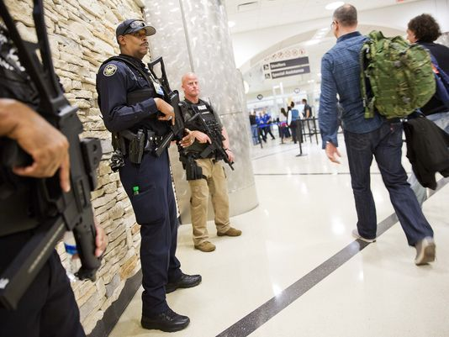
(Photo: David Goldman, AP)
CONNECTTWEET 128LINKEDINCOMMENTEMAILMORE
The recent terrorist attacks in Paris and Mali, not to mention the warnings for major cities around the world, have put many travelers on edge. For those of us who’ve already bought and paid for a trip, or are planning to travel in the near future, travel insurance might seem like a good idea. But what can it really do for you in these circumstances? Here are five myths about travel insurance and terrorism.

1. If there’s a terrorist incident in a country that I’m traveling to, I can cancel my trip and get a full refund.
Well, it’s complicated, and it involves a close reading of the fine print.
“If a traveler purchases a travel insurance plan that includes trip cancellation benefits before the incident occurs, they may be covered," says Phil Hsia, president of AIG Travel Americas, which includes Travel Guard insurance. “Travelers should review the portion of their particular plan dealing with trip cancellation, which should contain a list all of the reasons that can be covered should a traveler need to cancel or interrupt his or her trip.”

That said, if you do have a travel insurance policy that covers you for trip cancellation and trip interruption, it can often help, says Daniel Durazo, a spokesperson for Allianz Global Assistance USA. “If a terrorist incident happened at your destination within 30 days of your arrival, you would be covered.”
Where it can get tricky is the definition of “destination.” For example, say you had been planning a trip to Nice, in the south of France, nearly 600 miles south of Paris. In that event, it’s unlikely you would be covered. Unless, of course, you made the argument that you were flying through Paris to get there. In many instances, determining coverage is done on a “case-by-case basis,” Durazo says.
Timing is also important. You would need to purchase the policy before the trip commences, not during it.
“The policy must have been purchased and in effect before the incident occurred,” says Sharon Mostyn, a spokesperson for RoamRight. “For example, RoamRight travelers who purchased a policy before the [Paris] attack and are expected to be in Paris between Nov. 13, 2015, and Dec. 13, 2015, may be eligible for trip cancellation benefits.”

2. Travel insurance will cover me in the event that I’m injured in a terrorist incident.
Once again, read the policy closely.
“Travel insurance plans that cover emergency medical expenses should list the causes that are excluded,” says Hsia of AIG Travel Americas. “To confirm types of coverage on your travel insurance plan, look for both general exclusions, and any exclusions that apply specifically to medical expenses. If terrorism is not a listed exclusion, coverage could likely apply for an injury that is the result of a terrorist attack.”
Many companies, including RoamRight, can offer some help, says Mostyn. “Our security and medical experts will assess your situation and determine the best, immediate course of action. It’s important for U.S. travelers to remember that not every international destination will have the same standard of care that we are accustomed to receiving in the U.S. Our assistance provider can help you navigate the international healthcare systems and even evacuate you to a different hospital — or home — if medically necessary.”
This is where it can get tricky, however. Many travel insurance policies will cover you with a medical transfer to the closest most appropriate medical facility as determined by the insurance company. That could well mean a hospital in the destination where the incident occurred, a hospital that may very likely be overwhelmed with casualties. The only way to absolutely guarantee that you will be transported back home to a hospital of your choice is to buy a separate membership with a company like MedjetAssist, which arranges to transport you back to your hospital of choice on a medical flight regardless of where the incident occurred.
What a good travel insurance policy can do, says Durazo of Allianz Global Assistance USA, is help when the foreign hospital demands payment up front, a situation that can occur when you’re traveling abroad. Policies with a “payment guarantee,” he says, can be financial lifesavers “when you are faced with paying in advance.”

3. If I’m stuck in a country where there’s been a terrorist incident, my travel insurance policy will get me out of the country.
There are no guarantees, but the policy may help you. Hsia of AIG says that an important benefit of having coverage is helping out with logistics, which can be formidable in the wake of a terrorist attack.
“Many travel insurance plans offer 24/7 travel assistance services that should include emergency return travel arrangements and re-booking flights on the insured’s behalf,” he says. “If a customer who has purchased these services calls us and needs emergency assistance to leave the country, we will do our best to coordinate the effort on their behalf.”
Bear in mind that you don’t need to be planning a trip to Western Europe, Africa or the Middle East to consider some sort of coverage. Mostyn of RoamRight says that “the thought of a terrorist incident happening while you are out of the country is frightening, but keep in mind that we’ve experienced terrorist acts right here in the United States as well. Even when traveling domestically, a travel insurance policy will help you with the expenses and logistics associated with changes in your travel plans.”

4. If there’s a chance or a rumor of a terrorist attack where I’m heading, I can cancel my trip and trip insurance will cover me.
Rumors are rumors, and they are treated accordingly by travel insurance companies,
Hsia of AIG Travel Americas says that “most travel insurance plans will not list this as a covered reason to cancel the trip, as a terrorist incident usually must actually occur if coverage is going to apply. However, some plans offer an optional upgrade that allows an insured to cancel a trip for any reason and receive some percentage of the trip cost back.”
In fact, most travel insurance companies offer this upgrade, allowing you to cancel for any reason, with no questions asked. But beware that the price can be very steep indeed. Durazo of Allianz Global Assistance USA estimates that such a policy will run 25% more than a standard policy and in the event that you cancel and ask for a refund, you won’t get back 100% of your trip costs, but an amount closer to 75%.
5. If the U.S. State Department issues a “travel alert” or “travel warning,” I can cancel my trip with my travel insurance.
The U.S. State Department may seem prescient when they issue a travel alert or warning, but that won’t help you get reimbursed for an upcoming trip.
Mostyn of RoamRight says that “when considering a claim for reimbursement, coverage would be in effect if an event has been deemed a terrorist attack by the U.S. government.”
Warnings and alerts don’t count, in other words.
“As with rumored terrorist attacks, travel alerts or warnings are not a covered reason for trip cancellation on most travel insurance plans we are aware of,” says Hsia of AIG Travel Americas. “Therefore, a traveler may want to seek out a plan that allows them to add the cancel for any reason benefit.”

